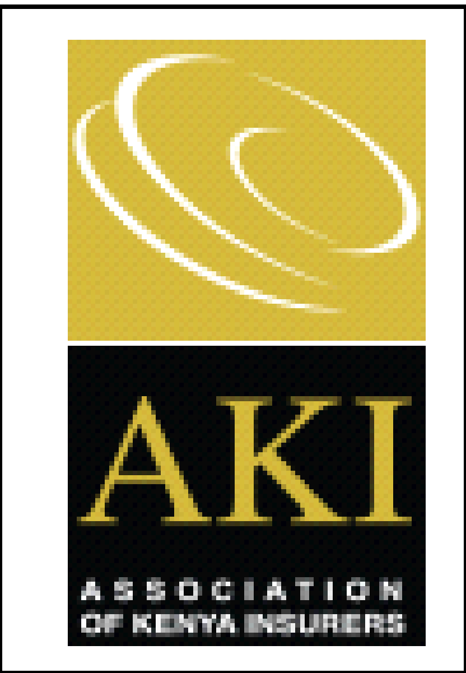

Weekly Media Watch
A weekly round-up of Insurance news coverage

Business Daily
UK-based global insurance solutions provider Linkham Group will acquire a majority stake in Resolution Insurance after agreeing to purchase 100 percent of the equity holding of LeapFrog Investments, a private equity firm backed by US billionaire investor George Soros and JP Morgan for an undisclosed sum. The firms said Thursday the agreement is subject to certain closing conditions, including regulatory approvals in Kenya, and is expected to complete within this quarter. The firms said in a statement that the Insurance Regulatory Authority (IRA) of Kenya has given them a nod to progress the transaction to completion. Read More

AAR seeks tech partner to improve online service delivery: Insurance firm AAR is looking for a strategic distribution and payment partner in the digital space as the company seeks to improve efficiency and cut costs. AAR Managing Director Nixon Shigoli said the company estimates it will need about Sh100 million to link to a fast and seamless system that will allow the company to deploy insurance cover within a day.“We want to rely on a technology driven Launchpad especially on the process side. If you pay for a cover today you will get the insurance availed in the same day,” Mr Shigoli said in an interview. Read More

Daily Nation

CIC settles loan for Covid victims: Listed underwriter CIC Group has settled loan balances for more than 164 families who died from Covid-19 pandemic, worth Sh143 million. Read More

The Standard
UK firm stake in Kenya insurer: UK-based company Linkham Group will acquire a stake in Resolution Insurance after agreeing to p purchase 100 percent of the holding of the private equity firm Leapfrog investments for an undisclosed sum. The agreement is subject to certain conditions including regulatory approvals and is expected to be completed this quarter. Read More

The Star
Police unit in Kitui receives beds, donations for its health facilities: Health facilities at the border police unit and boarder police training campus in Kitui have received beds and other equipment's to help improve services. They also received face masks to help them in preventing the spread of covid-19.Madison life insurance company made the donations to the officers. Read More

Pension funds returns drop 57% on Covid-19 impact:
Retirements schemes recorded median return of 7.3% over the January to December 30 2020 period, mainly on business a survey shows. Top managers in the survey included Gen Africa with 97 schemes, Old Mutual Investments group (85 Schemes), Sanlam Investments Easy Africa (73), Co-op Trust Investments (59) and ICEA Lion Asset management with 56 schemes. Read More

Social media watch...
Kenyan Wall Street: Linkham Group Acquires Majority Stake in Resolution Insurance: UK based insurance firm, Linkham Group, has announced plans to acquire a stake in Resolution Insurance after purchasing 100% of the equity holding in the company from private equity impact investment firm, Leapfrog Investments, for an undisclosed amount. LeapFrog Investments invested $18.7million for a majority stake in Resolution Insurance in 2015, through Resolution Health East Africa Limited; the latter’s holding company. However, the acquisition is subject to certain closing conditions, including regulatory approvals in Kenya, and is expected to be finalized within this quarter. The Insurance Regulatory Authority (IRA) of Kenya gave the parties a nod to follow the transaction to completion.
https://kenyanwallstreet.com/linkham-acquire-stake-in-resolution-insurance/

Capital Digital: APA Increases Its Covid-19 Response Donation: APA Life has donated 1000 children’s reusable face masks to Cheleta Primary School. The move has seen the company through APA Apollo Foundation donate over 10, 000 masks to some of the most disadvantaged communities in Kenya. APA Life Chief Executive Officer, Catherine Karimi says one of the best ways to protect others from the corona virus is by wearing a face mask, “Masks work best when everyone is wearing them to protect those around them. Masks are a key way everyone can help contain the pandemic and we are pleased to donate the masks to the students of Cheleta Primary School. The Children will benefit and help keep them safe,” she noted. The APA Apollo Foundation has so far contributed Sh10 million towards supporting vulnerable people in the wake of Covid -19 pandemic.

https://www.capitalfm.co.ke/business/2021/02/apa-increases-its-covid-19-response-donation/

Hapa Kenya: Resolution launches online self-service platform to enhance service delivery: Resolution Insurance has launched an online self-service platform that will allow its customers to access its products and services more efficiently. Dubbed Resolution Now, the digital platform will enable the insurer to capitalize on the power of technology to remodel its business and way of working to create a transformative customer experience. Speaking during the launch, Ms. Alice Mwai, Managing Director Resolution Insurance, said, “At Resolution Insurance we promise to give more access to our products and services. We have been making bold moves to remain relevant to our customers with our new offerings and new ways of accessing our services on demand. We are committed to staying true to this promise and that is why we have heavily embraced technology and innovation in developing solutions that will see customers receive quick and prompt customer service.”

https://hapakenya.com/2021/02/09/resolution-launches-online-self-service-platform-to-enhance-service-delivery/

